x1=0, x2=1, x3=2, x4=3, x5=4

y1=2, y2=3, y3=5, y4=4, y5=6

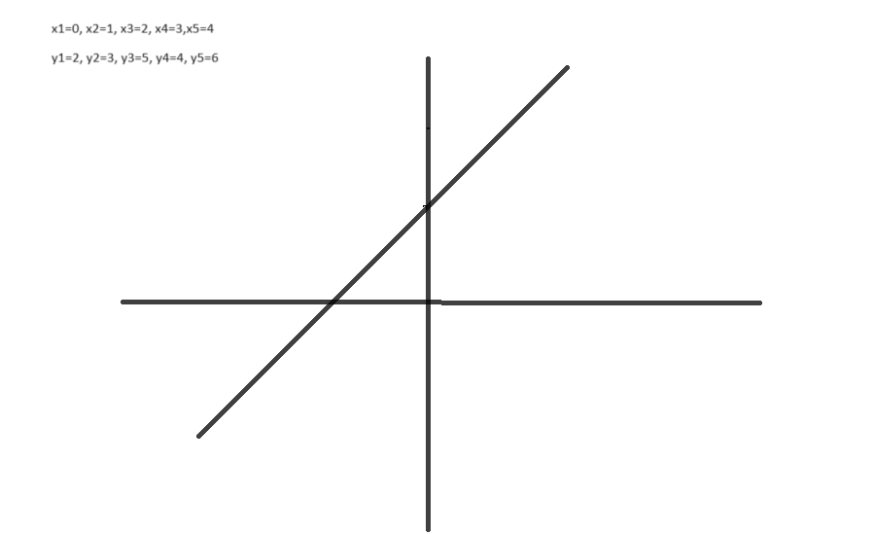

The equation of straight line is

Y=mx+C

where m is slope, c is intercept

m=y2-y1/x2-x1

m=1

C=2

1: Y=C+mx1+mx2+mx3+mx4+mx5

=2+0+1+2+3+4

=12

2: If values of x=10 then

Y=mx+c

=1\*10+2

=12